Individual Care Plan for Students with Type 1 Diabetes
Daily and Emergency Procedures

IDENTIFICATION | Name: ______________________________________ Date of birth: ______________ School year: 20___ to 20___  School: ________________________________ Grade: ______ Homeroom teacher: ________________________  Home address: ______________________________________________________  Medical contact: _________________________ Phone: _____________________  If student has another care plan, note here: _______________________________  Designated staff to provide support with diabetes care (minimum 2):  1. _______________________________________________________________  2. _______________________________________________________________  3.________________________________________________________________  STUDENT  PHOTO  Before-school care: No Yes _________________ After-school care: No Yes _____________________  School bus #: a.m.___________ p.m.___________
CONTACTS | Name Relationship Preferred phone # Alternate phone #  1st  2nd  3rd
EMERGENCY KITS / SUPPLIES | SCHOOL must ensure a kit is accessible at all times (class, gym, field trips, lockdowns, fire drills, etc). Advise parents when running low on supplies. PARENT must maintain/refresh supplies.  CONTENTS (check all that apply) With student Classroom Office Other location(s)  Blood glucose meter, test strips, lancets  Fast-acting sugar (juice, glucose tabs, candy) for low blood sugar  Carbohydrate snack(s)  Glucagon (expiry date: ___/___)  Sharps disposal container  Ketone strips/meter  Insulin pen, pen needles, insulin (in case of pump failure)  Extra batteries for meter  Parents’ names and contact numbers  Other:

Once this care plan is complete, parents should fill in the quick-reference sheet shown below, which outlines the major routine tasks to be done each day. Indicate which, if any, tasks the student needs help with. Keep a copy in each classroom and all locations (eg., gym) where the student spends part of the school day. Download the file at www.diabetesatschool.ca

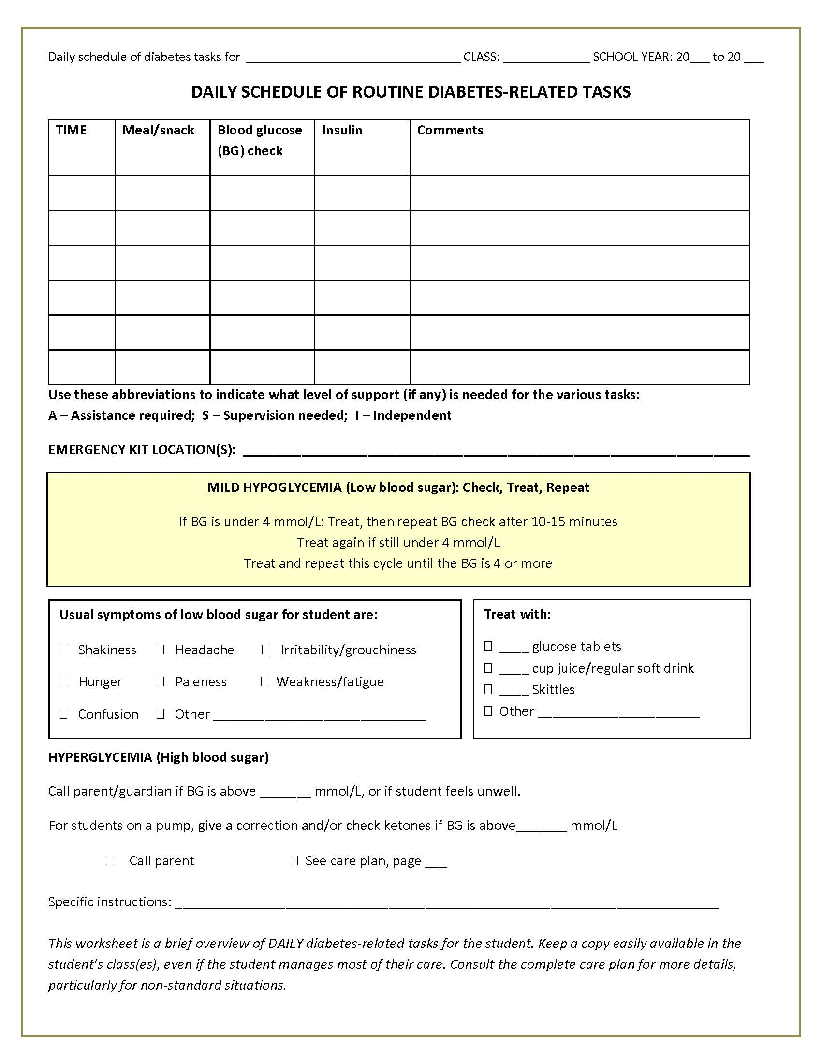

EMERGENCY PROCEDURE FOR LOW BLOOD SUGAR (HYPOGLYCEMIA)

 | MILD-TO-MODERATE LOW BLOOD SUGAR | SEVERE LOW BLOOD SUGAR
SYMPTOMS | When blood sugar (BG) is low, the student may have these symptoms:  - Shakiness - Irritable/grouchy - Dizziness  - Sweating - Blurred vision - Headache  - Hunger - Weakness/fatigue - Paleness  - Confusion - Other(s)___________________________  The student may also use these words to describe feeling low: __________________________________________________ | Symptoms  - Unresponsive or unconscious  - Having a seizure  - So uncooperative that you can’t give juice or sugar by mouth  What to do  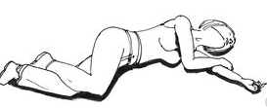  - Place the student in recovery position.  - Have someone call 911. Then call parents.  - Stay with the student until ambulance arrives. Do not give food or drink (choking hazard).  - If there is a signed consent and mutual agreement (see p. 8) to give glucagon, give it now.  - Yes, give glucagon  - No, do not give glucagon  _____________________  HOW TO USE NASAL GLUCAGON  - Remove shrink wrap. Open lid. Remove the device from tube  - Hold the device between fingers and thumb  - Insert the tip gently into one of the nostrils until finger(s) touch the outside of the nose (1).  - Push the plunger all the way in. Dose is complete when green line is no longer showing (2).  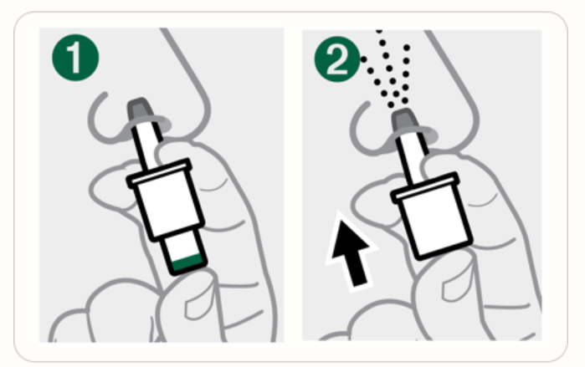  - Once student is alert, give juice or fast-acting sugar.
ACTION | Never leave a student with a low blood sugar alone.  Treat the low blood sugar ON THE SPOT.  Do not send the student somewhere else.  First, check blood sugar (BG). Even students who do their own checks may need help when their blood sugar is low. Then follow these steps:  When BG is over 4 mmol/L:  - If meal or snack is more than 1 hour away, give snack now  - If meals or snack less than 1 hour away, no action needed. Student can eat at regular time  How much fast-acting sugar to give  √ 10 g 15 g  Glucose tablets (4 g each) 2 tabs (8 g) 4 tabs (16 g)  Juice or regular soft drink ½ cup ¾ cup  Skittles 10 pieces 15 pieces  Rockets (roll candy) 1 roll (7 g) 2 rolls (14 g)  Table sugar 2 tsp / 2 pkgs 1 Tbsp / 3 pkgs
When BG is under _______ mmol/L, call parent

PROCEDURE FOR HIGH BLOOD SUGAR (HYPERGLYCEMIA)

DEFINITION | Hyperglycemia = high blood glucose/sugar (BG). Levels may vary by individual.  High blood sugar is usually the result of extra food or inadequate insulin, but not always. BG also rises during illness or stress, and can be due to technical problems (pump failure, missed meal bolus, etc).
SYMPTOMS | The student may use these words to describe a high blood sugar: _____________________________________  Usual symptoms of high blood sugar for this student are:  - Extreme thirst - Frequent urination - Headache  - Hunger - Abdominal pain - Blurred vision  - Warm, flushed skin - Irritability - Other: __________________  Usual symptoms of SEVERE high blood sugar  - Rapid, shallow breathing - Vomiting - Fruity-smelling breath
ACTION | Check BG. Even students who do their own checks may need help if they are unwell.  - If student has symptoms of illness: Call parent immediately if student is unwell, has severe abdominal pain, nausea, vomiting or symptoms of severe high blood sugar. A parent should pick up the student from school if blood sugar is high and they feel unwell, regardless of how old or independent they are.  - No symptoms of illness: If the student feels well and the BG is under ______ , no immediate treatment is needed. Note the blood sugar reading using the typical home-school communication method. In the meantime:  - Allow free access to the washroom and encourage them to drink water/sugar-free fluids.  - Allow student to eat usual meal or snack (they may chose carbohydrate-free snacks).  - Allow student to resume activity as normal.  - Insulin corrections by pump: If the student is on an insulin pump, a correction may be given (see insulin section of this plan). If BG has not decreased 2 hours after the correction, call parent.
When BG is above _______ mmol/L, call parent
KETONES | - This student does not check for ketones at school.  - If BG is above ______, check ketones using urine sticks OR ketone blood meter  Urine stick Blood meter Action  If ketones are Negative to small Less than 0.6 Proceed as for hyperglycemia above  Moderate to large At or above 0.6 May indicate pump failure or extra insulin needed. Call parents for instructions.

 |  | ROUTINE |  | MANAGEMENT
BLOOD GLUCOSE/SUGAR (BG) MONITORING |  | Student’s target  blood sugar (BG) range  ______to _____mmol/L  - Student requires trained staff to do a blood sugar (BG) check and read the meter  - Student needs supervision to do a BG check and read the meter  - Student can do a BG check and read the meter on their own  Location of glucose meter(s)  - With student  - Homeroom class  - Other(s) ________________  Allow student to check their blood sugar at any time, in any place, respecting their wish for privacy or company. |  | Always check blood sugar when student shows symptoms of hypoglycemia.  If you are not able to check, treat as if blood sugar is low.  Student’s blood sugar should be checked at these times each day:  Time Time  - Before a.m. break _____ - At before-school program ____  - Before lunch _____ - Before breakfast program ____  - Before p.m. break _____ - At after-school program ____  - Before leaving school _____ - Before sport or exercise  Other times: ___________________________________________________  Home-school communication method:  Daily blood sugar readings should be communicated to parents via:  € Agenda € BG readings form € Text messages € Other _____________  Call parent if blood sugar is:  - Below ____  - Above ____  Does student wear a continuous glucose monitor (CGM)?  - No  - Yes  - Yes, sometimes.  - If yes, see Appendix B.
NUTRITION BREAKS |  | - Student needs supervision during meal/snack times to ensure all food is eaten  - Student can manage their food intake independently  Allow enough time to eat meals/snacks.  Ensure student eats meals/snacks on time.  No food sharing. |  | € Student can eat snack and lunch at regular school times.  If not, specify when the student should eat _______________________________________________________  _______________________________________________________  Student requires a snack before:  - End of day/getting on bus  - Physical activity (see next section, page 6).  When treats or classroom food is provided:  € Student/school should contact parent in advance for instructions  € Student can manage independently  Food restrictions  - Celiac disease: no gluten-containing products  - Allergies/intolerances: ____________________________________________
 |  |  | ROUTINE |  | MANAGEMENT
 | PHYSICAL ACTIVITY |  | BG meter and fast-acting sugar should ALWAYS be accessible during physical activities.  Risk of low blood sugar increases during/after physical activity.  The student may need extra BG check(s) and/or extra food.  - Student can make decisions about physical activities independently  - Student needs supervision/guidance around physical activity |  | Notify parents whenever special activities are planned (for example, Terry Fox run, track and field day, field trip or other active event)  - No action needed before activity  - Check blood sugar before regular physical activity classes  - Check blood sugar before unplanned activity  Comments: __________________________________________________________  ________________________________________________________________________________________________________________________________________  If blood sugar is:  - Under 4 mmol/L, treat for low blood sugar  - Between 4 mmol/L and ____ , give a snack before activity  - Above _____, no snack is needed before activity  For students on a pump:  - No specific pump adjustments needed  - Suspend/disconnect pump for activity. Store ________________  - Other________________________________________________
 | INSULIN |  | € Student does not take insulin at school.  € Student takes insulin at school by:  - pen injection  - pump  - syringe*  Insulin is given by:  € Student, independently  € Student, with supervision  € Designated staff  € Parent  € Other _____________  Location in school where insulin will be given  _______________________  * Consider using pens at school because dosing is easier |  | Complete this section only if student takes insulin at school.  Insulin by injection/ pump is done at the following times:  - Before breakfast program Time ________  - Before morning snack ________  - Before lunch ________  - Before afternoon snack ________  - Other ________________  If BG is above ______ mmol/L, call parent  For students using insulin pen/syringe:  - Insulin can only be given at breakfast and/or lunchtime  For students using an insulin pump:  - Insulin can be given anytime the student is eating  - There must be 2 hours between correction doses

 | ROUTINE | MANAGEMENT
INSULIN VIA PUMP | A bolus calculator (which parents will provide) must be used in school settings. The pump is always programmed at home.  Designated staff are responsible for ensuring that:  - the BG reading and number of carbohydrates are entered at each meal/snack time  - the bolus is delivered | Training is required. The basic steps are:  - Check BG before the student eats. The reading will:  € Be sent to the pump by the meter.  € Need to be manually entered into the pump.  - Enter the total number of carbohydrates to be eaten (provided by parent or the student)  - The pump will calculate the amount of insulin to be given. Press the appropriate button to accept and deliver the bolus.  If BG is above _____ mmol/L:  - Check ketones  - Call parent  - Other _________________________________________
INSULIN VIA PENS OR SYRINGE | Type of insulin used:  __________________  Always double-check the insulin dose before injecting to make sure the appropriate dose has been selected and is dialed correctly into the pen.  - The student is able to select the appropriate dose. Designated staff should double-check the dose.  - Insulin is given by designated staff. A second adult must check the dose. (This task requires some training, but the adult doing it does not need to be a designated staff member listed in this care plan).  - Parents agree the student can give their own insulin, without an adult double-checking the dose. | Training is required. Here is how the dose is calculated:  - Parents label the student’s food with number of carbohydrates and provide a Bolus Calculator Sheet* that allows designated staff to select an appropriate insulin dose. This dose is based on the BG reading and the number of carbohydrates the student will eat.  OR  - Same steps as above, but with the dose calculated by the student’s glucose meter (only certain meters can do this).  - Parents will send a set number of carbohydrates for snack/lunch each day. They will provide an appropriate tool (such as variable dose insulin scale in Appendix A) to help designated staff select appropriate dose based on the student’s BG.  - Parents may send a different number of carbohydrates for snack/lunch each day (clearly labeled) and will provide an appropriate tool (such as variable dose insulin scale in Appendix A) that allows designated staff to select a dose of insulin based on BG.  Parents have the right to adjust insulin dose for bolus calculator sheet  or sliding scale throughout the school year as needed  * See www.bcchildrens.ca/health-info/coping-support/diabetes,  Click on Basal-Bolus Insulin with MDI, then Bolus Calculators for School Lunches

CONSENT | Pre-authorizations by parents/guardians  Consent to release information: I authorize and provide consent to the school staff to use and/or share information in this plan for purposes related to the education, health and safety of my child. This may include:  - Displaying my child’s photograph on paper notices or electronic format(s) so that staff, volunteers and school visitors will be aware of my child’s medical condition.  - Communicating with bus operators.  - Sharing information in special circumstances to protect the health and safety of the student.  Yes No  Consent to transfer to hospital: I consent in advance to my child’s being transported to a hospital if required, based on the judgment of school staff. I also permit a staff member to accompany my child during transport. Please note: the school principal or designate shall decide if an ambulance is to be called.  Yes No  Consent to treatment: I am aware that school staff are not medical professionals and perform all aspects of the plan to the best of their abilities and in good faith. I approve of the management steps and responses outlined in this care plan, including administering glucagon if indicated.  Yes No  Agreement to provide glucagon: School staff, parents and my child (if age-appropriate) agree that glucagon can be given in the event of severe hypoglycemia. Note: School personnel must sign below to indicate pre-agreement to provide this emergency medication. Information: www.diabetesatschool.ca/schools/glucagon  Yes, glucagon can be given No, glucagon cannot be given
AUTHORIZATION | Parent/guardian signature:_______________________________ Date: _____________________  Parent/guardian name (print):_____________________________ Relationship:________________  Student signature: __________________________________________________________________  Heath care professional (HCP) signature: _________________________ Date: _________________  HCP name (print): ______________________________________ Role: _______________________  Principal signature: __________________________________________________________________  Principal name: ______________________________________________________________________  Designated and trained staff (minimum 2):  1. ____________________________________________________________________________________  2. ____________________________________________________________________________________  3. ____________________________________________________________________________________  Staff trained and designated to administer glucagon: ____________________________________________

ANNUAL RENEWAL
When requirements change significantly, complete a new Individual Care Plan and share with all involved.

If there are no changes between school years, use this sign-off sheet to confirm the plan has been reviewed by the school, the parent(s) and, when age-appropriate, the student.
This plan remains in effect for the ______ to ______ school year without change.

Parent/guardian:_____________________________________ Date: ____________________

Principal: ___________________________________________ Date:____________________

This plan remains in effect for the ______ to ______ school year without change.

Parent/ guardian:_____________________________________ Date: ____________________

Principal: ___________________________________________ Date:____________________

This plan remains in effect for the ______ to ______ school year without change.

Parent/ guardian:_____________________________________ Date: ____________________

Principal: ___________________________________________ Date:____________________

This plan remains in effect for the ______ to ______ school year without change.

Parent/ guardian:_____________________________________ Date: ____________________

Principal: ___________________________________________ Date:____________________

This plan remains in effect for the ______ to ______ school year without change.

Parent/ guardian:_____________________________________ Date: ____________________

Principal: ___________________________________________ Date:____________________

APPENDIX A (page 1 of 2)
How to calculate lunchtime insulin using variable dose insulin scale

For a student using insulin pens or syringes, calculate a lunchtime insulin dose in one of two ways:

- FIXED dose: A set amount of insulin to match a set number of carbohydrates for each meal.
- RATIO: 1 unit of insulin for a specific number of carbohydrate grams (Number of carbs / Ratio = dose)
Before eating, always check blood sugar. If BG is:
- Within target range: Give the usual FIXED dose or calculate using RATIO and number of carbs in the meal.
- Too low: Treat the low blood sugar. When calculating the lunchtime insulin dose, do not include the carbohydrates used to treat the low.
- Too high: Add extra insulin (a correction) to the dose.
How to calculate a correction dose
- Adjustment scale: An amount of insulin is added (or subtracted, if BG is low) from the dose, depending on the BG level.
- Correction factor (CF; Also called insulin sensitivity factor, ISF): An estimate of how much 1 unit of rapid-acting insulin will lower BG for a specific person. To calculate the amount of insulin needed to correct a high blood sugar using this method, the formula is: [BG−6] divided by CF (correction factor)
- The student’s fixed dose of insulin for lunch is _____ units for _____ carbohydrates
- The student’s ratio is 1 unit of insulin for every _____ of carbohydrates
- The student’s correction factor is _______
Start with the dose for lunch | ____units (fixed dose)
 | 1 unit of insulin per ___grams of carbohydrates = ____
Check BG. What range is it in? | Below  4 mmol/L | TARGET  -
Then (add to OR subtract from) dose

APPENDIX A (page 2 of 2)
How to calculate lunchtime insulin using variable dose insulin scale

Examples

1. Susan has a ratio. This is her adjustment scale:

Lunch dose | 1 unit per 10 grams of carbohydrates
Lunchtime BG | Below  4 mmol/L | TARGET 4 – 7 mmol/L | 7 – 10 mmol/L | 10.1 – 14 mmol/L | 14.1 – 17  mmol/L | Above 17
Adjustment  ( − or +) | − 1 unit |  | +1 units | +2 units | +3 units | +4 units

On Monday, her BG is 11.5 mmol/L. She plans to eat 50 grams of carbs for lunch.

Insulin for food = 50/10 = 5 units
Correction for BG + 2 units

Total insulin 7 units

On Tuesday, her BG is in her target range at 6.4 mmol/L. She plans to eat 45 grams of carbs for lunch.

Insulin for food = 45/10 = 4.5 units
Correction for BG + 0 units

Total insulin 4.5 units

2. Max uses a correction factor rather than a scale:

- His ratio is 9.
- Correction factor is 2

The formula is [BG−6] / CF. Max’s BG is 13.2 mmol/L and he plans to eat 50 grams of carbs for lunch.

Correction = 13.2 – 6 = 7.2/2 = 3.7

Round to the nearest ½ unit = 3.5 units

Insulin for food = 50/9 = 5.5 units
Correction for BG + 3.5 units

Total insulin 9 units

APPENDIX B

Using Continuous Glucose Monitors in School
- A Continuous Glucose Monitor (CGM) is a monitoring device that is inserted every 6 to 7 days and automatically provides readings every 5 minutes, day and night. A sensor, inserted underneath the skin, it measures “interstitial glucose”, or the glucose found in the fluid between cells. The sensor sends this information wirelessly to a monitor.
- A CGM provides a constant picture—a pattern as opposed to a “moment-in-time” snapshot that comes from intermittent fingerprick readings.
- A CGM does not replace traditional BG testing. Fingerpricks are still needed at least twice a day to calibrate the CGM, and are recommended before meals to guide insulin dosing, and to confirm any alerts that require treatment.
- If the CGM and meter results differ, the meter BG is considered the most reliable. Parents may choose to use the CGM reading before snacks and activity. That is an individual decision and depends on how accurate they consider the CGM to be. See the table below for guidance.
- BG readings are sent to an insulin pump or to a remote device where they can be tracked. Some families are able to access their child’s CGM readings remotely on their smart phone. The results are available in real time and can also be uploaded and reviewed by parents at the end of the day.
- Some pumps have a feature called “Low Glucose Suspend” (LGS), where the pump will automatically stop delivering insulin for 2 hours if the BG is low and the user hasn’t responded.
- While most students with a CGM will also be using an insulin pump, a CGM can also be used by those taking insulin by injection.

 | ROUTINE | MANAGEMENT
CGM – CONTINUOUS GLUCOSE MONITOR | Student wears a CGM:  - Always  - Sometimes  - Never  - The student is independent in their response to CGM results and alarms (excluding severe hypoglycemia)  - Student needs help to respond to the CGM results and alarms  - Results are sent to:  - Insulin pump  - Remote device  - Parent smartphone  - Low glucose suspend (LGS) is active on pump.  - If yes, the threshold is set at ______ mmol/L. | - Low BG alarm is set at: _________ mmol/L  Low BG alarm should be confirmed with a BG check. Respond as per hypoglycemia section of this plan.  - High BG alarm is set at: _________ mmol/L OR € No alarm set for highs  High BG alarm should be confirmed with a BG check. Respond as per hyperglycemia section of this plan.  - Also, BG checks are to be routinely done at the following times (check all that apply).  € Before lunch  € Before all snacks  € Before gym/activity  € Other _______________________________________________  - If Low Glucose Suspend comes on, check BG by meter and follow care plan for action:  - If BG is below _____ mmol/L, treat and re-check in 15 minutes.  - If BG is above _____ mmol/L, cancel LGS. No treatment required.

